**UpdateModel: -**

**UpdateModel()** is a Controller helper method that inspects all the **HttpRequest** inputs such as **Posted Form data, QueryString, Cookies, and Server variables** and attempts to populate the explicit model object you indicate as a parameter. Essentially, it is used only for model binding.

UpdateModel() is used to update the model with the Form data & perform the validations. It throws an exception if validation fails.

e.g.

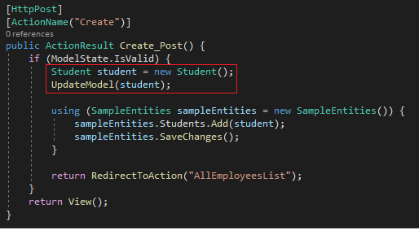

**TryUpdateModel: -**

**TryUpdateModel()** is a Controller helper method that inspects all the **HttpRequest** inputs such as **Posted Form data, QueryString, Cookies, and Server variables** and attempts to populate the explicit model object you indicate as a parameter. Essentially, it is used only for model binding.

TryUpdateModel() is used to update the model with the Form data & perform the validations. It does not throw an exception if validation fails.

